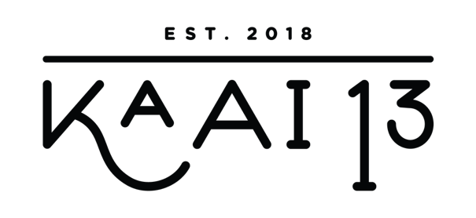
NAGERECHTEN & SPECIAAL KOFFIE

CHOCOLADE TRUFFELTAART 9,50
VANILLE IJS, SLAGROOM

WARME APPELTAART 8,50
VANILLE IJS, SLAGROOM

DAME BLANCH 9,00
CHOCOLADESAUS, VANILLE IJS, SLAGROOM

AFFOGATO 7,00
VANILLE IJS, ESPRESSO, SLAGROOM

ESPRESSO MARTINI 13,00
ESPRESSO, KALHUA, VODKA

IRISH COFFEE 8,00
IERSE WISKEY, RIETSUIKER, KOFFIE, SLAGROOM

ITALIAN COFFEE 8,00
AMANDEL LIKEUR, KOFFIE, SLAGROOM

FRENCH COFFE 8,00
GRAND MANIER, KOFFIE, SLAGROOM

D.O.M. COFFEE 8,00
DOM BENEDICTINE, KOFFIE, SLAGROOM

SPANISH COFFEE CLASSIC 8,00
TIA MARIA, KOFFIE, SLAGROOM

SPANISH COFFEE MODERN 8,00
LICOR 43, KOFFIE, SLAGROOM
DESSERT & COFFEE SPECIAL

CHOCOLAT TRUFFLE PIE 9,50
VANILLA ICECREAM, WHIPPED CREAM

WARM APPLE PIE 8,50
VANILLA ICECREAM, WHIPPED CREAM

DAME BLANCH 9,00
CHOCOLAT SAUCE, VANILLA ICECREAM, WHIPPED CREAM

AFFOGATO 7,00
VANILLA ICECREAM, WHIPPED CREAM

ESPRESSO MARTINI 13,00
ESPRESSO, KALHUA, VODKA

IRISH COFFEE 8,00
IRISH WISKEY, SUGAT, COFFEE, WHIPPED CREAM

ITALIAN COFFEE 8,00
AMANDEL LIKEUR, COFFEE, WHIPPED CREAM

FRENCH COFFE 8,00
GRAND MANIER, COFFEE, WHIPPED CREAM

D.O.M. COFFEE 8,00
DOM BENEDICTINE, COFFEE, WHIPPED CREAM

SPANISH COFFEE CLASSIC 8,00
TIA MARIA, COFFEE, WHIPPED CREAM

SPANISH COFFEE MODERN 8,00
LICOR 43, COFFEE, WHIPPED CREAM
DESSERT & COFFEE SPECIAL

CHOCOLAT TRUFFLE PIE 9,50
VANILLA ICECREAM, WHIPPED CREAM

WARM APPLE PIE 8,50
VANILLA ICECREAM, WHIPPED CREAM

DAME BLANCH 9,00
CHOCOLAT SAUCE, VANILLA ICECREAM, WHIPPED CREAM

AFFOGATO 7,00
VANILLA ICECREAM, WHIPPED CREAM

ESPRESSO MARTINI 13,00
ESPRESSO, KALHUA, VODKA

IRISH COFFEE 8,00
IRISH WISKEY, SUGAT, COFFEE, WHIPPED CREAM

ITALIAN COFFEE 8,00
AMANDEL LIKEUR, COFFEE, WHIPPED CREAM

FRENCH COFFE 8,00
GRAND MANIER, COFFEE, WHIPPED CREAM

D.O.M. COFFEE 8,00
DOM BENEDICTINE, COFFEE, WHIPPED CREAM

SPANISH COFFEE CLASSIC 8,00
TIA MARIA, COFFEE, WHIPPED CREAM

SPANISH COFFEE MODERN 8,00
LICOR 43, COFFEE, WHIPPED CREAM
NAGERECHTEN & SPECIAAL KOFFIE

CHOCOLADE TRUFFELTAART 9,50
VANILLE IJS, SLAGROOM

WARME APPELTAART 8,50
VANILLE IJS, SLAGROOM

DAME BLANCH 9,00
CHOCOLADESAUS, VANILLE IJS, SLAGROOM

AFFOGATO 7,00
VANILLE IJS, ESPRESSO, SLAGROOM

ESPRESSO MARTINI 13,00
ESPRESSO, KALHUA, VODKA

IRISH COFFEE 8,00
IERSE WISKEY, RIETSUIKER, KOFFIE, SLAGROOM

ITALIAN COFFEE 8,00
AMANDEL LIKEUR, KOFFIE, SLAGROOM

FRENCH COFFE 8,00
GRAND MANIER, KOFFIE, SLAGROOM

D.O.M. COFFEE 8,00
DOM BENEDICTINE, KOFFIE, SLAGROOM

SPANISH COFFEE CLASSIC 8,00
TIA MARIA, KOFFIE, SLAGROOM

SPANISH COFFEE MODERN 8,00
LICOR 43, KOFFIE, SLAGROOM

